Introduction of C Programming Language

This practical is for review or introduction of C programming language.

In this session, you can have some basic ideas about C language (if you have not used C programs, you can see the first two sections in “C_Tutorial.htm” at http://www.physics.drexel.edu/students/courses/Comp_Phys/General/C_basics/c_tutorial.html).

Then, you can write your first C program - helloWorld.c. You will also understand C types from a C program in this practical.

Task1: Get yourself familiar with the VMWare Player and Ubuntu

1. Starting the VMWare player and Ubuntu

When Windows has loaded, click Start, then find VMWare Player and click it. This starts a Virtual Machine. Click Ubuntu-2008 (or 2009) (or open ubuntu-2008.vmx) and wait for Linux to finish loading on the Virtual Machine. This could take some time. Be patient! You may need to click on the virtual machine window to allow you give input directly into the virtual machine. Press CTRL+ALT to return to Windows.

2. Switch to a command line terminal

After you log into the Ubuntu system, you are placed at a graphical terminal. Switch to a command-line terminal by double click Terminal to open a BASH shell prompt as follows:

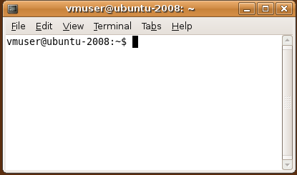

3. You may try basic unix/linux commands:

pwd (show your current directory), ls (dir), cd, mkdir (md), rm (del), mv (rename or move to another directory), cp (copy), vi (for editing). You may need to see Basic Linux Usage.

4. Set PATH to include the current directory:

vmuser@ubuntu-2008:~$ export PATH=$PATH:.
5. Create a C file using a text editor:
vi helloWorld.c (or using text editor in Applications to create helloWorld.c)

/*
* File name: helloWorld.c
* The helloWorld program simply displays "Hello World!"
* to the standard output.
*/

#include <stdio.h>

int main()
{
printf("\nHello World !\n");
}

6. Compile the C file: gcc -o helloWorld helloWorld.c
7. Run your C file: helloWorld

VMware can be found at: http://www.vmware.com/

Task2: Testing types’ sizes

Download “typeSizes.c” and save it into a USB stick and then plugin the USB flash pen (you may need to wait for a while) into your computer. You also can use folder in “Places” to transfer data between the flash disk (the USB) and the “file system”, for example, you can copy “typeSizes.c” from the “disk” to “vmuser”.

Read this c file and try to understand C types and the size of various C variable types and constructs (please talk to your tutor if you have any problem). You can also compile and run it:
Compile the C file: gcc -o typeSizes typeSizes.c
Run your C file: typeSizes

Exercise questions:
Q1) Describe the differences between symmetric and asymmetric multiprocessing. What are three advantages and one disadvantage of multiprocessor systems?

Q2) What is the purpose of interrupts? What are the differences between a trap and an interrupt? Can traps be generated intentionally by a user program? If so, for what purpose?

Home Reading:
C Tutorial – see “C_Tutorial.htm” at http://www.physics.drexel.edu/students/courses/Comp_Phys/General/C_basics/c_tutorial.html

